ENABLE-S3 Final Event

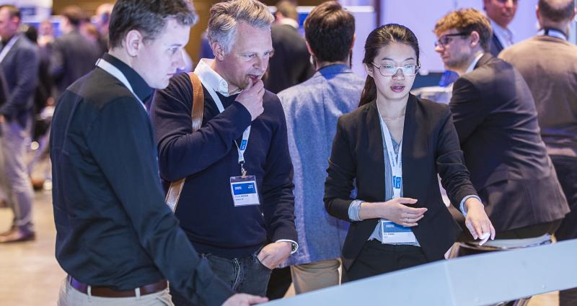

**ENABLE-S3 presents results at Final Event**

The European research project ENABLE-S3, funded through the ECSEL JU programme, successfully presented the results of three years of research at the public Final Event May 16-17 May in Graz, Austria.

Coordinated by AVL List, 68 partners from 16 countries had set themselves the goal of establishing a comprehensive platform for the cost-effective validation and verification of autonomous and highly automated vehicles, trains, tractors, ships, aircraft, satellites and medical examination equipment.

In the course of three years, the research consortium has collaborated across 6 domains and 12 industrial-driven use cases and achieved impressive results. At the Final Event in Graz, the most important project results were presented to project partners, the ECSEL JU appointed reviewers, the project officer, guests and visitors.

To facilitate the understanding and gain an overview of the results, both visitors and guests had the chance to participate in guided tours through the exhibition with more than 40 demonstrators. Additional, exclusive guided tours were organised for the reviewers and the project officer.

To support the collaborative spirit of the project and to connect with people driving innovations in renowned companies, keynote presentations were held by representatives from autonomous driving programmes within Siemens and Intel/Mobileye and the German regulation organisation TÜV SÜD. How the ENABLE-S3 results are already being applied in standardization activities were shown by ASAM e.V. and by the Austrian proving region for automated driving ALP.Lab.

Overall, the presented results were well received and the project consortium, guests and visitors enjoyed the fruitful exchange of knowledge and the collaborative spirit among all event participants.

If you want to learn more about the project results, please check the ENABLE-S3 homepage <https://www.enable-s3.eu/media/dissemination-material/>